How to access the webmail:
Go to http://webmail.hccs.edu or https://outlook.office365.com/
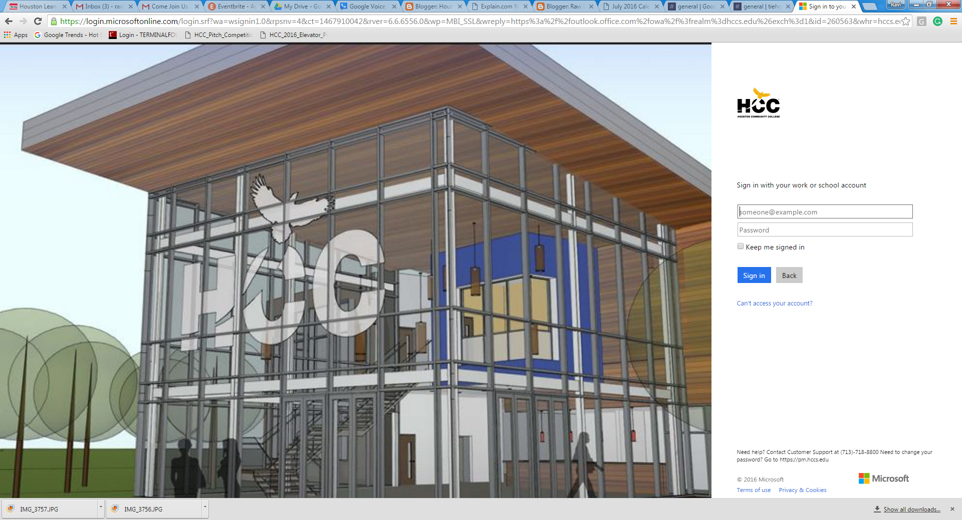
How to setup Email forwarding:
Once logged in, click on the “Settings” option, which is the Gear Icon, on the top Left side of the window.
Click on the “Mail” Options and select “Forwarding” menu link. Choose Start Forwarding Radial button and enter your email address that you wish to forward your emails to.
Click the Save button to save your changes.

