Summer 2023 I Student News

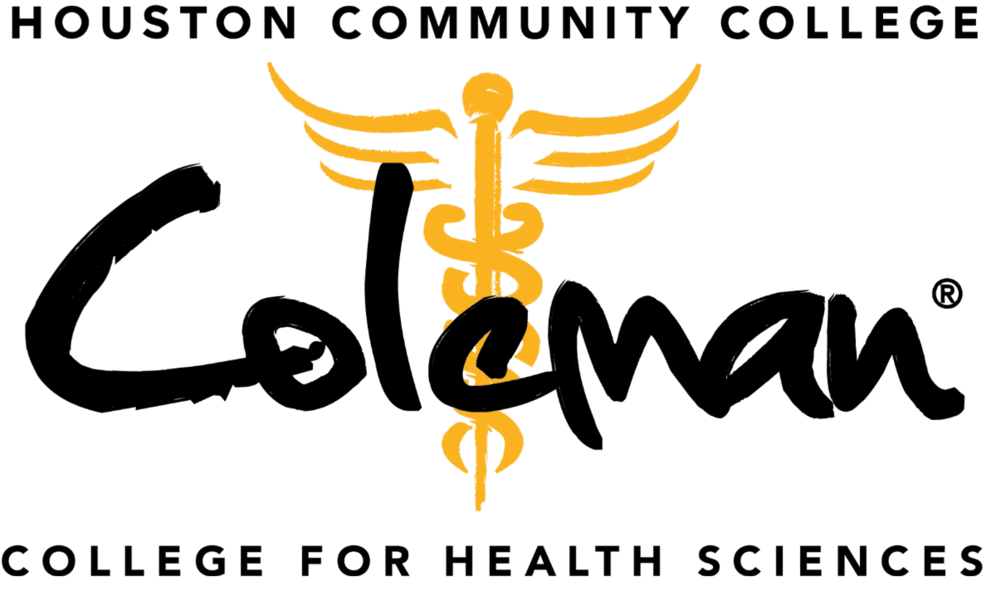

Class of 2023 Pinning Ceremonies
Health Information Technology
Ten Health Information Technology graduates received their pin at the pinning ceremony on July 19 at Coleman Tower Atrium.
See the photos!

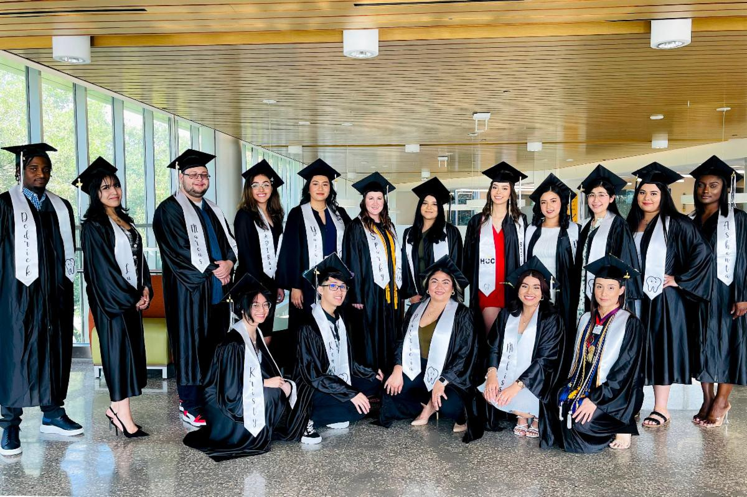
Dental Assisting
Twenty-five Dental Assisting graduates received their pin at the pinning ceremony on July 27 at Coleman Tower Atrium.
See the photos!

Medical Assistant
Thirteen Dental Assistant graduates received their pin at the pinning ceremony on July 28 at Coleman
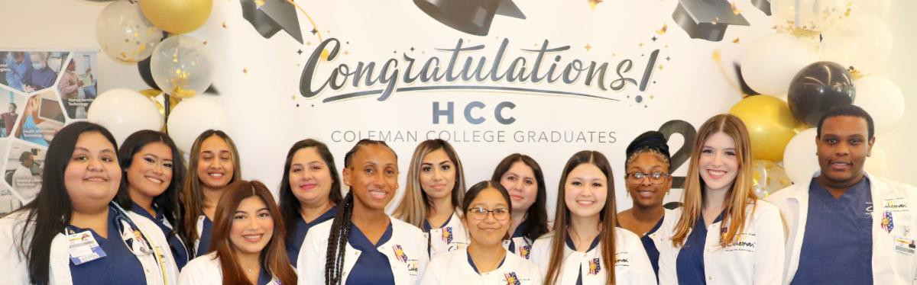
Tower Atrium.
See the photos!

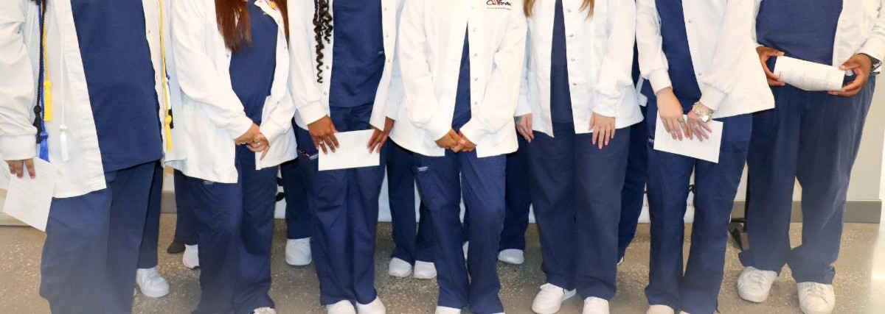

Respiratory Therapy
Thirteen RespiratoryTherapy graduates received their pin at the pinning ceremony on July 28 at Coleman Tower Auditorium.
See the photos!

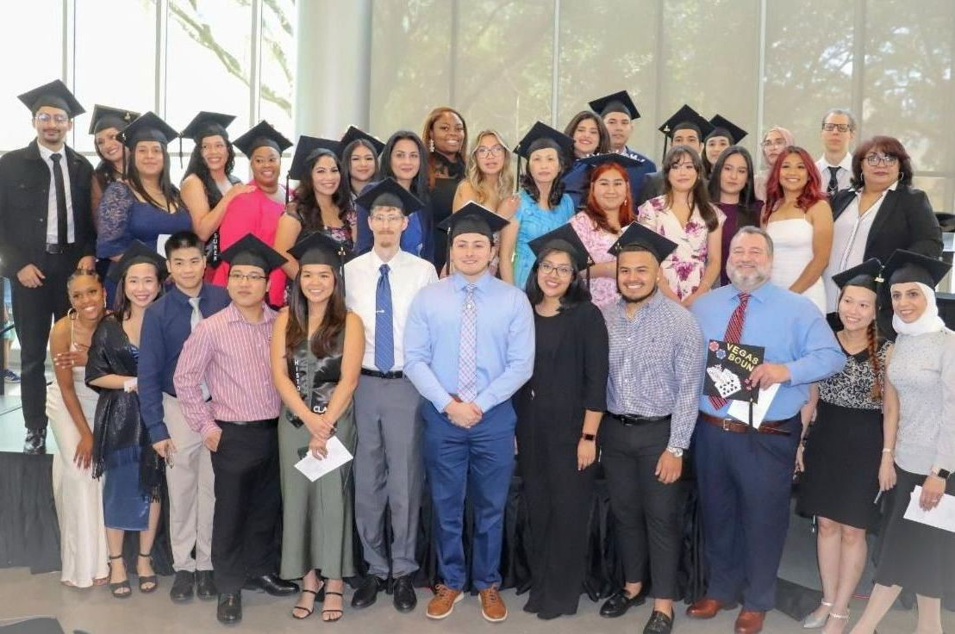
Radiography
Thirty-five Radiography graduates received their pin at the pinning ceremony on July 29 at Coleman Tower Atrium.
See the photos!

Pharmacy Technician
Twenty-one Pharmacy Technician graduates received their pin at the pinning ceremony on Aug. 24 at Coleman Tower Atrium.
See the photos!

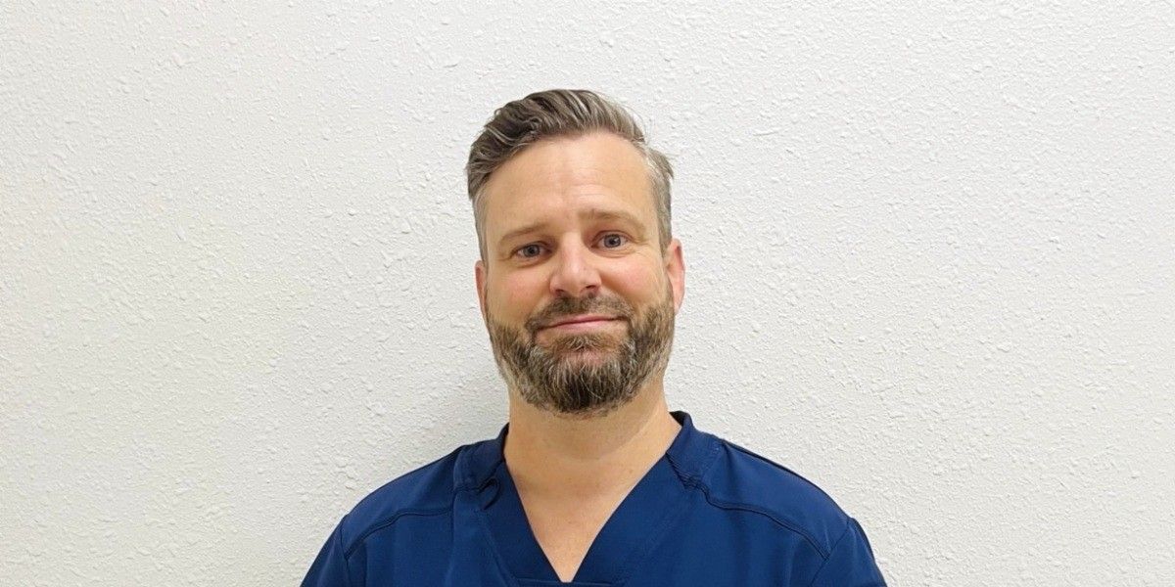
Soaring Students

Coleman Champion: Minh Pham

Read his profile!
Reel Talk: Jasmine Batts

Hear her testimonial
Coleman Colleague: Robert Jones, 2022

Read his profile!

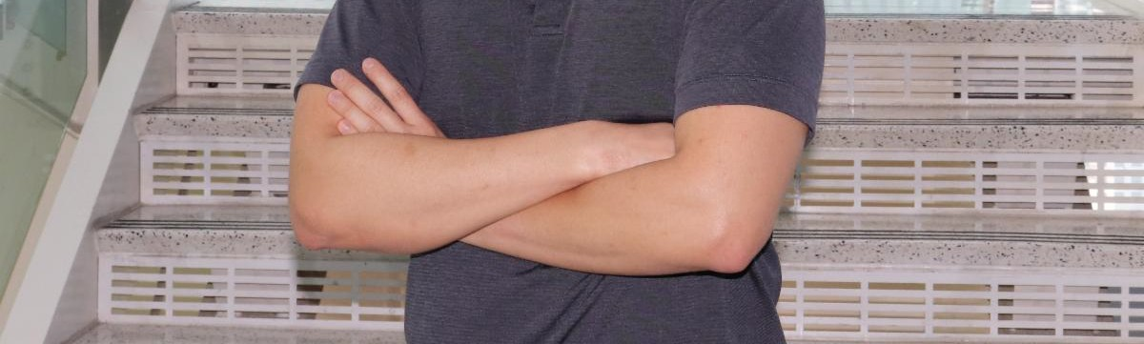
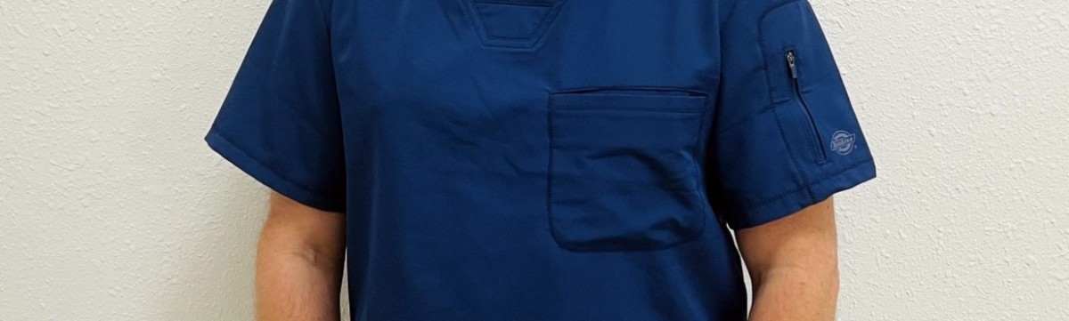

Do you have some Eagle news to share?

Email Coleman Communications!

PDF Version

HCC Coleman College | 1900 Pressler St., Houston, TX 77030

Unsubscribe co.communications@hccs.edu Update Profile |Constant Contact Data Notice Sent byco.communications@hccs.edupowered by

Try email marketing for free today!

